Expression of Interest
ExxoLift On-Farm Trial Pilot (AS25201)
Exoskeleton Trials for Safer and More Productive Horticulture
Exxovantage®, in partnership with Hort Innovation Frontiers, is inviting growers to express their interest in joining a new on-farm pilot project to trial ExxoLift™, a wearable assistive solution designed to reduce physical strain during manual tasks.
Preliminary results from early applications have shown significant reductions in movement-related injury risks of up to 64%, along with improvements in worker comfort and overall wellbeing, and worker productivity increases. This project aims to further validate these benefits in real commercial horticulture settings.

What is ExxoLift™?
ExxoLift™ is a lightweight, wearable exosuit worn like a backpack that supports workers’ backs during physically demanding bending, reaching, lifting and twisting tasks such as:
- Picking / Packing / Stacking
- Logistics / palletisation / loading / unloading
- Nursery / Husbandry / Pruning
It is designed to reduce strain on the body without restricting movement, helping workers reduce fatigue, stay safe and be more productive across a range of on-farm activities.
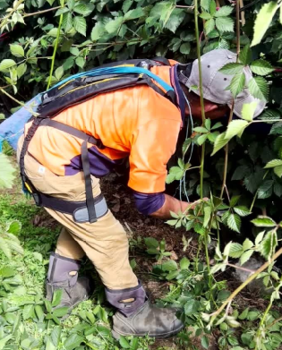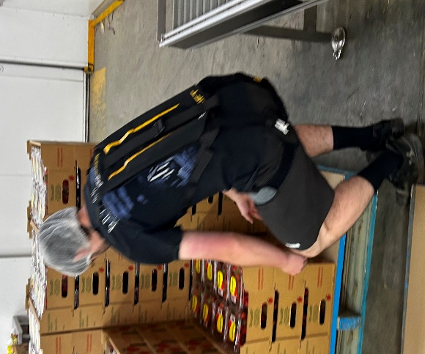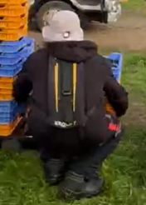

What is involved?
Selected growers will have the opportunity to:
- Participate in an on-farm pilot to test the ExxoLift™ solution
- Gain an onsite AI Wearable Sensor task risk assessment analysis for all workers included
- Trial the technology across multiple day-to-day tasks on their farm
- Provide practical feedback to help assess safety, wellbeing and productivity outcomes
A small co-funding contribution is required from participating growers, with the majority of project costs supported through Hort Innovation Frontiers.
Growers keep the ExxoLift™ exosuits at the end of the trial.

Trial timeframe
- Expected trial duration: 2-3 months
- Start dates will be confirmed with successful applicants

Who should express interest?
This opportunity is suitable for growers who:
- Rely on manual labour for repetitive or physically demanding tasks
- Are interested in improving worker safety and wellbeing
- Are open to trialling new practical solutions on-farm

How to express your interest
To register your interest in joining the pilot
please click or scan below:
EOI Email: scott@exxovantage.com
Or CLICK HERE to email an EOI to Exxovantage
Scan to email Exxovantage

